Project 1: Animal Crossing Villagers Q& A

- How Many Villagers are there?
  - There were 392 Villagers available in the original data set. However, new villagers continue to be introduced and there are currently 413 known villagers
- What types and how many of each species of animal
  - There are the following:
    - 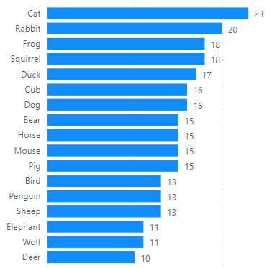
- Are the genders balanced?
  - Yes, there are 48% female villagers and 52% male villagers
  - 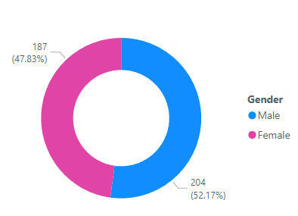
- What personality types are there?
  - There are 8 different personality types:
    - Big Sister, Cranky, Jock, Lazy, Normal, Peppy, Smug and Snooty
- Can you predict an animals type based on other known factors?
  - There was not an accurate model to predict a villager’s animal type based on known factors. However, Personality type is based on an animal’s gender.

